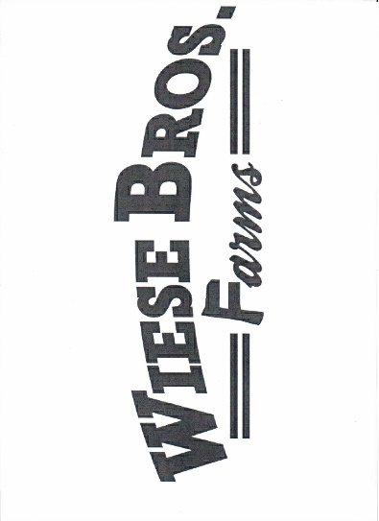
2024 Brown County
Breakfast on the Farm
Wiese Brothers Farm
Sponsorship Form

Brown County Dairy Promotion’s Mission:
To plan, initiate, and implement a series of dairy promotional events designed to attract urban and rural residents and educate them on the various aspects of the dairy industry. Brown County Dairy Promotions, Inc is a 501c3, your contributions are tax deductible.

Sponsor Incentives:
Sponsors will receive one meal ticket with each $100 cash donation or in-kind donation. Sponsors who respond prior to May 17, 2024 will have their names included on the sponsor board. This board shows recognition received for each level the day of the event. Sponsors will be identified in the Bronze, Silver, Gold, Diamond, and Platinum levels.

Bronze Level | Silver Level | Gold Level | Diamond Level | Platinum Level
Sponsor Board | Sponsor Board | Sponsor Board | Sponsor Board | Logo on Sponsor Board
Breakfast Tickets | Breakfast Tickets | Breakfast Tickets | Breakfast Tickets | Breakfast Tickets
 | Website Recognition | Website Recognition | Website Recognition | Logo on Website
 |  | Group Post on Facebook | Individual Post on Facebook | Individual Post on Facebook with Logo
 |  |  |  | Your banner hung at Breakfast

Sponsorship Levels:
Please make checks payable to:
Brown County Dairy Promotions
16929 Nachtwey Rd
Maribel, WI 54227

***Please Note Address Change***
Level | Cash and In Kind Donations
Platinum | $2000 and Above
Diamond | $1000 - $1999
Gold | $500 - $999
Silver | $250 - $499
Bronze | $100 - $249

If you have any questions, please contact Kristy Theunis, Chairperson at 920-371-1404 or email at kristytheunis@cornettefarmsupply.com.
Please include the bottom portion with your donation. (Please Print)

Business Name:____________________________________________________________________________
Contact Person: ____________________________________________________________________________
Address: __________________________________________________________________________________
City, State, WI: ____________________________________________________________________________
Donation Amount or In-Kind Donation Value: ____________________________________________________
Name on Facebook page: _____________________________________________________________________
E-mail Address: ____________________________________________________________________________

