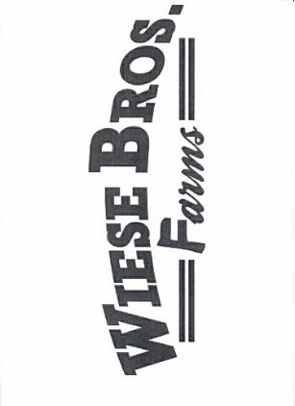
Welcome to Wiese Brothers Farm!

Wiese Brothers is a 3 generation, family-owned farm. Agriculture roots run deep for our Wiese family. Our family of 14 children grew up on a dairy farm in De Pere, with our parents Wilfred and Mae Wiese. Wilfred bought the current Greenleaf farm in 1973, running beef cattle and cash cropping with 6 of his sons.

In 1982, brothers Ken, Bob, Dick, Dan, Dave and Mark began Wiese Brothers Farm with the continued focus on raising beef cattle and cash cropping mostly corn, wheat and alfalfa. The alfalfa was mostly used at their pellet mill in Hilbert, Fox Valley Alfalfa Mill, which is still currently operated by the Wiese family.

Fast forward to 1995, when Wiese Brothers built the dairy that is on Old Hwy 57 and began milking 2500 cows. Another parlor was added in 2011 and another 2500 cows were added to the existing herd. Through the years, barns, feed pads, housing for 5000 heifers and another manure pit were added to the existing property.

In 2008, a feed mill was built on the property to mix our own rations for feeding the herd. A commodities building was added in 2022 to store needed ingredients for feed. In 2023, the Brown County Organics Digester was built near the farm, and the dairy supplies much of the manure to make sustainable natural gas for the community.

Today, Wiese Brothers is run by Dave and his son Ross, Mark and his son, Jonathan, and their brother Daniel’s son, Dan. Together we run 7200 acres, oversee the milking of 6500 cows, along with dairy manager, Scott Blevins. We have a crew of 100 full and part-time employees.

We are proud and humbled to be hosting Breakfast on the Farm. We couldn’t do what we do without the dedication of our families, our wonderful employees and all the vendors who support us every day. We work hard to be good stewards of the land and use the latest technology to ensure we are as efficient as possible. We are blessed to be able to work side by side with family and employees we call friends.

We’d like to thank our families, committee members, the countless volunteers, vendors, neighbors, friends, and sponsors who helped make this day possible. We believe that showcasing dairy farms through Breakfast on the Farm, is a great way to educate future generations the opportunities agriculture provides and pass on an appreciation for the hard work all farmers put in every day to provide food for the world.

Family and employees of Wiese Brothers Farms
